**Visualize Data using Amazon QuickSight**

In this project, I create visualizations from a large dataset using Amazon S3 and Amazon Quick sight. We'll be working with a dataset of 50,000 best-selling products on Amazon.com.

Step #1: Download the Dataset

Navigate to 2-s3-quicksight to download the "Amazon Bestseller Dataset"

[https://github.com/techwithlucy/youtube/tree/main/2-s3-quicksight](https://github.com/techwithlucy/youtube/tree/main/2-s3-quicksight%20)

CSV file and the "manifest.json" file.

Click on "raw" and Control+S to save both files onto your computer.

Step 2:Create an s3 bucket

* Go to your Aws Management console

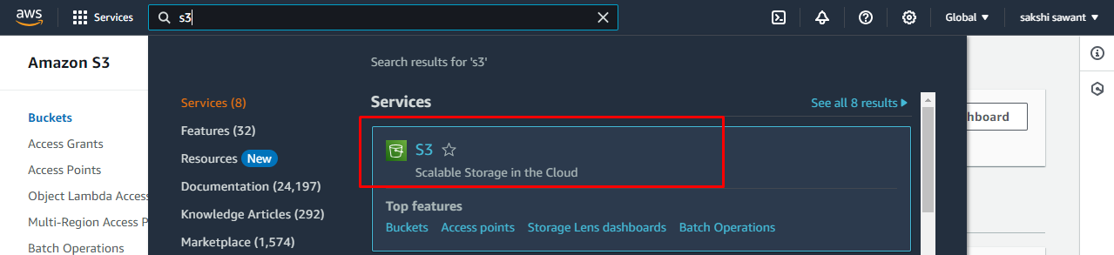

* Once you on the Bucket page click to “Create Bucket”

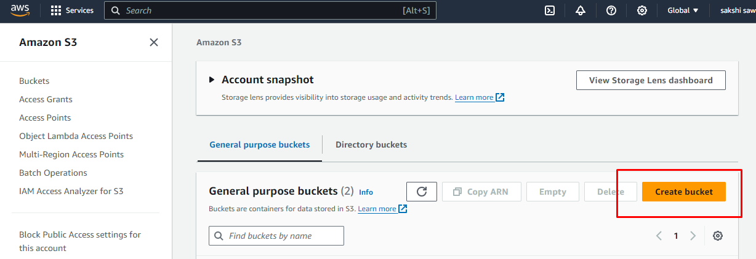

* I am going to name it “**sakshi-amazon-project**” you can keep it anything you like.
* Keep everything as default and scroll all the way down and select

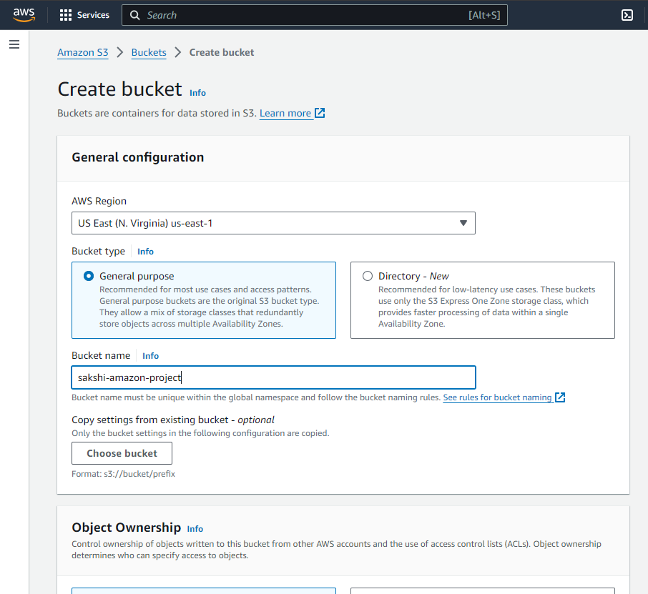

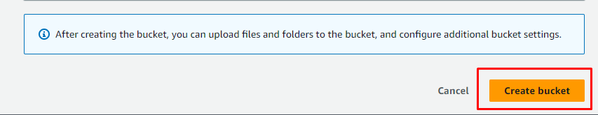

**Step #2: Store the Dataset in Amazon S3**

* Click on your bucket you just created.
* Upload the CSV file and the "manifest.json" file into the bucket.



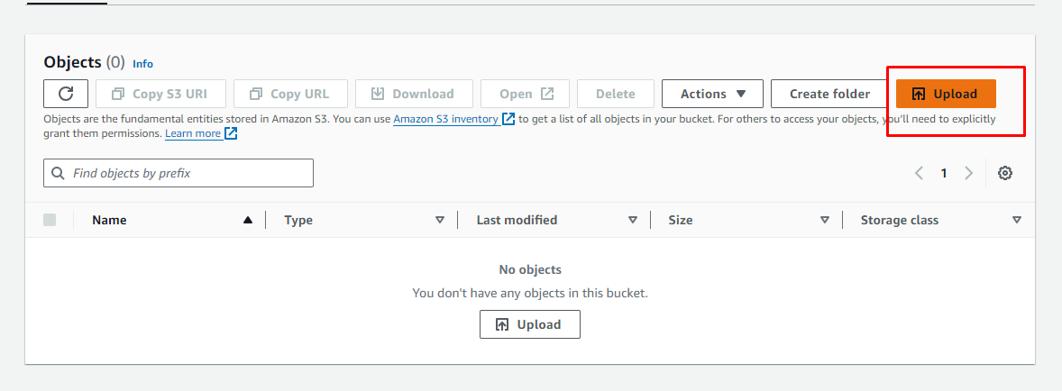

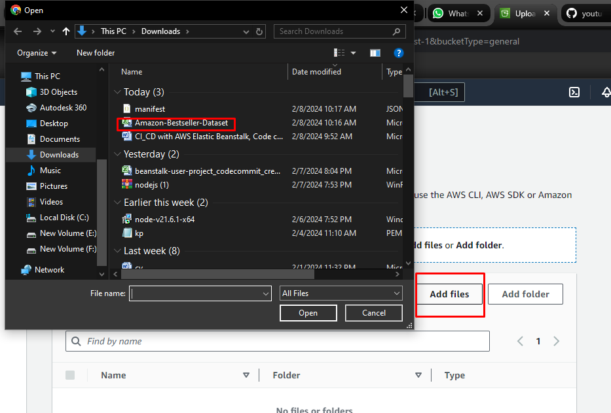

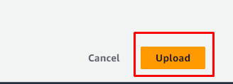

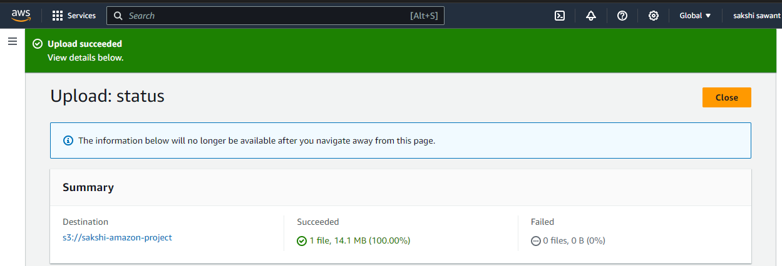

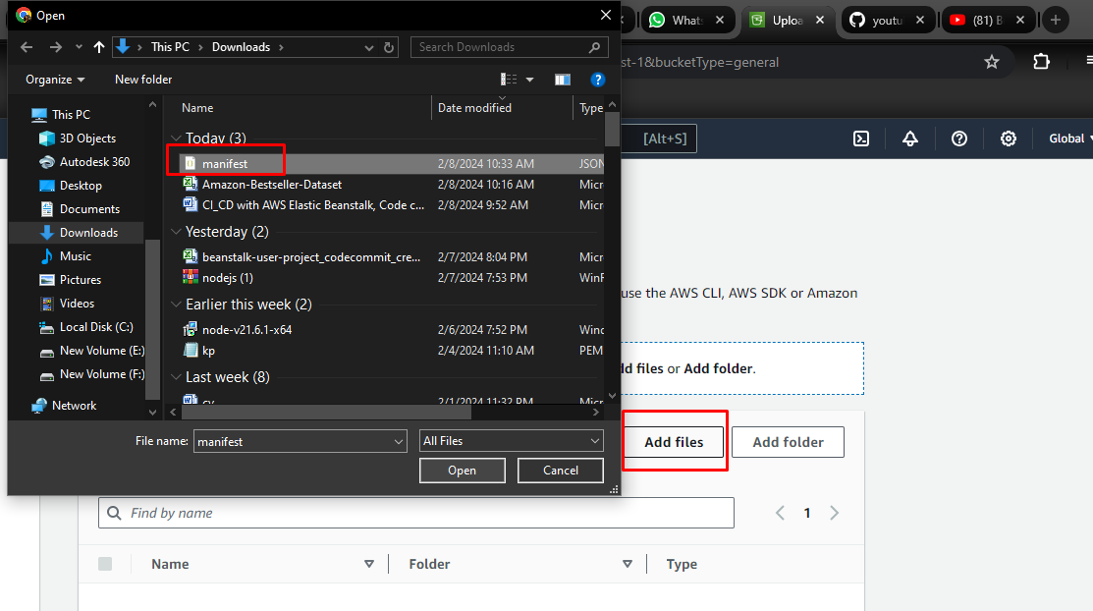

Step #3: Connect S3 Bucket with Amazon Quicksight

* Open the AWS management console and navigate to Amazon Quicksight.
* Sign up for a free trial of the Enterprise edition if you don't have an account.
* Select Amazon S3 and tick the box for the S3 bucket you created.
* Enter the link to your "manifest.json" file and connect to Quicksight.
* Select "interactive sheet" to start creating visualizations.

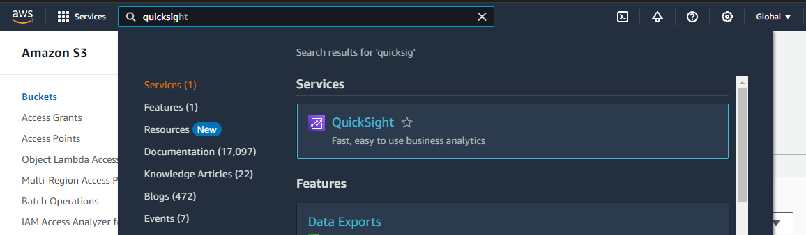

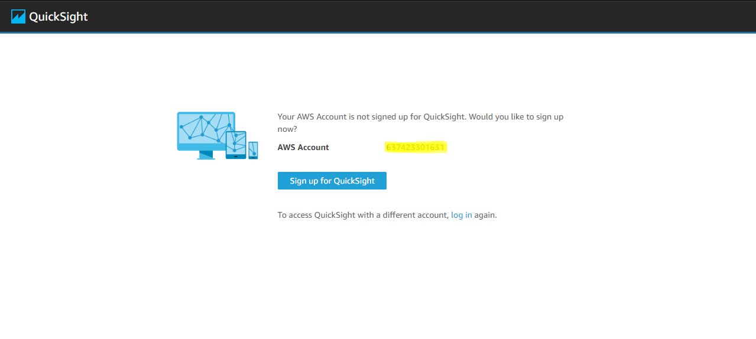

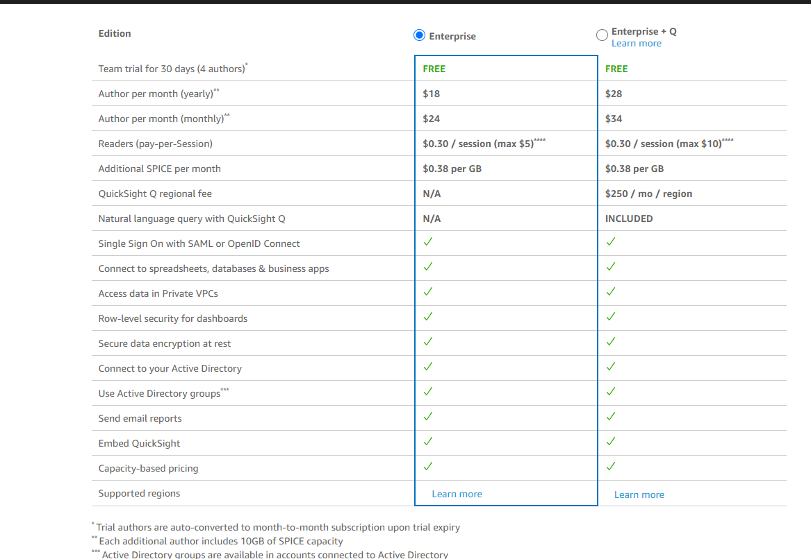

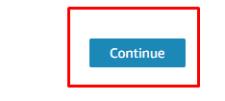

* Just make sure you cancel your subscription before 30 days

To avoid unnecessary charges

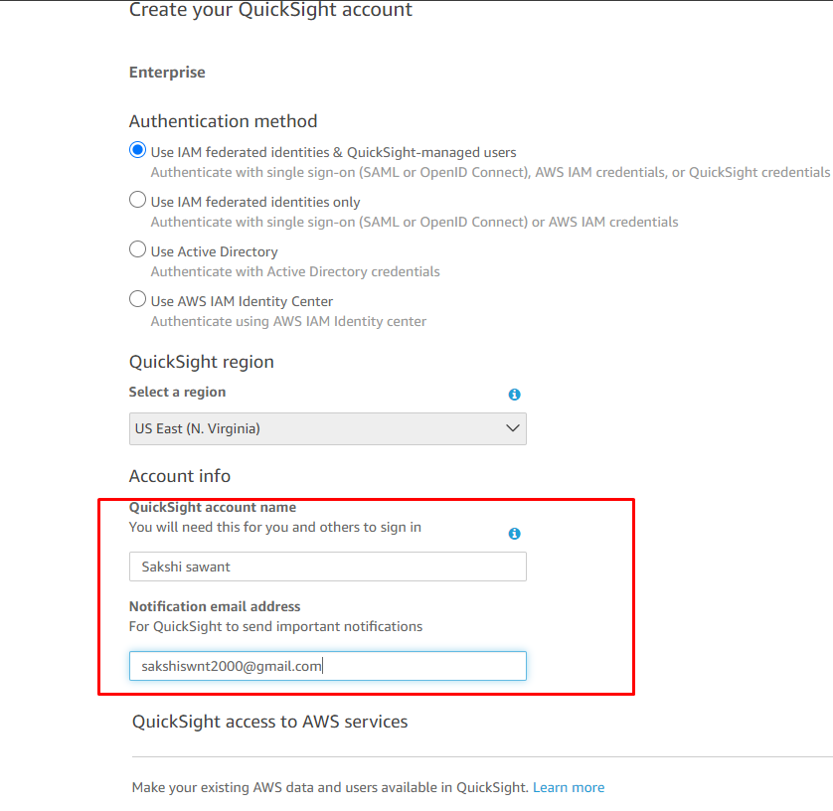

Make sure to select s3 bucket that you want to link to quick sight

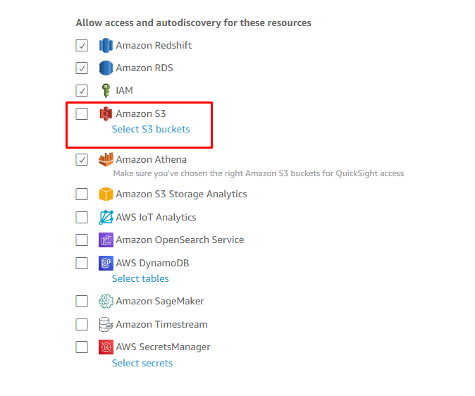

* Keep everything rest as default and click on finish

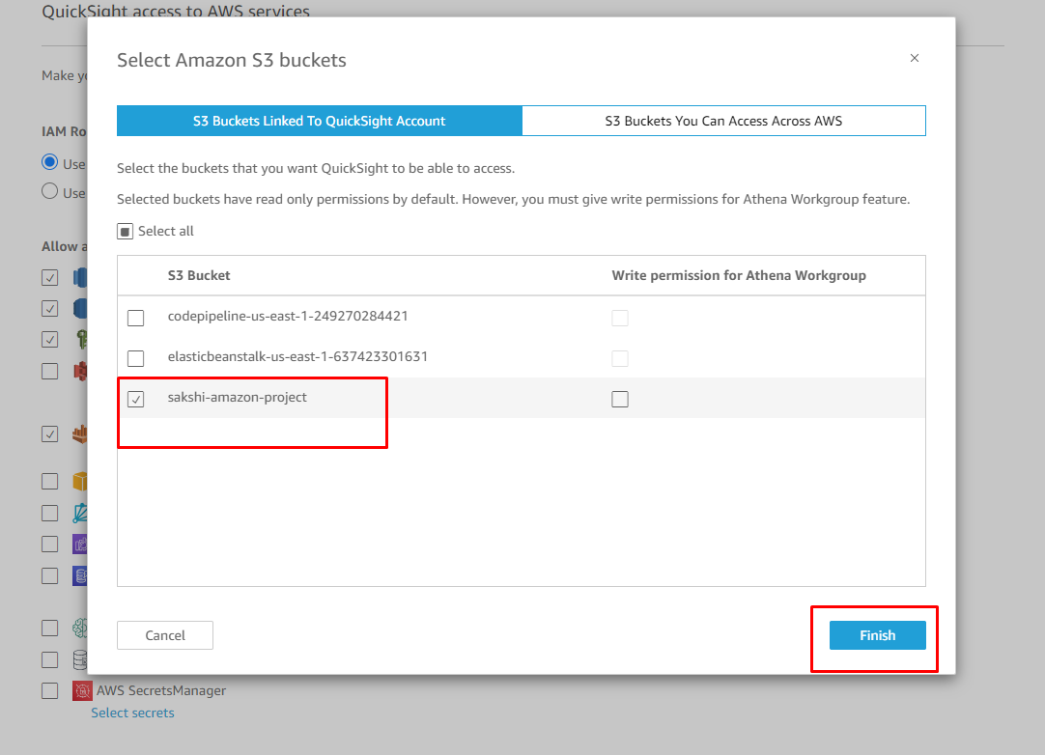

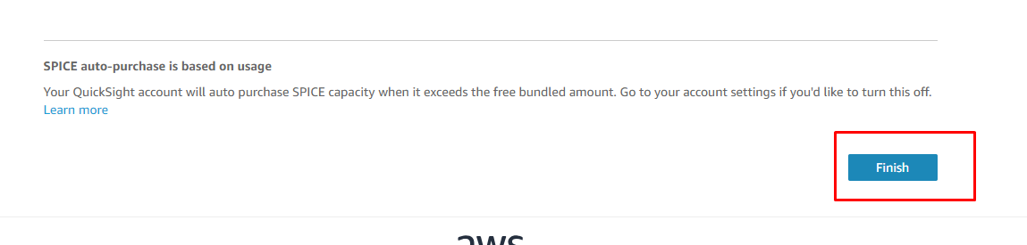

* We going to click on go to amazon quicksight

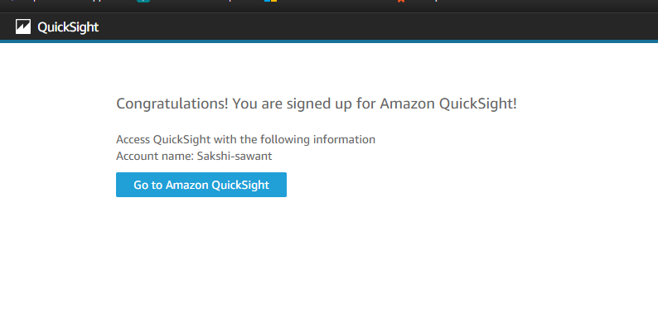

* And now you can see amazon quicksight interface

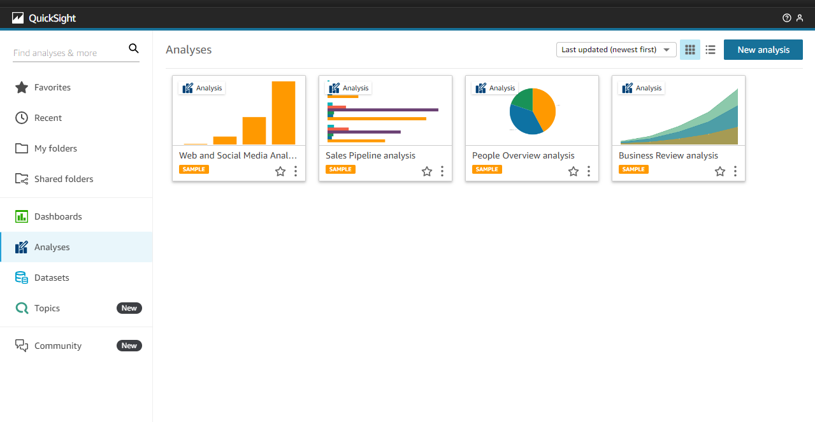

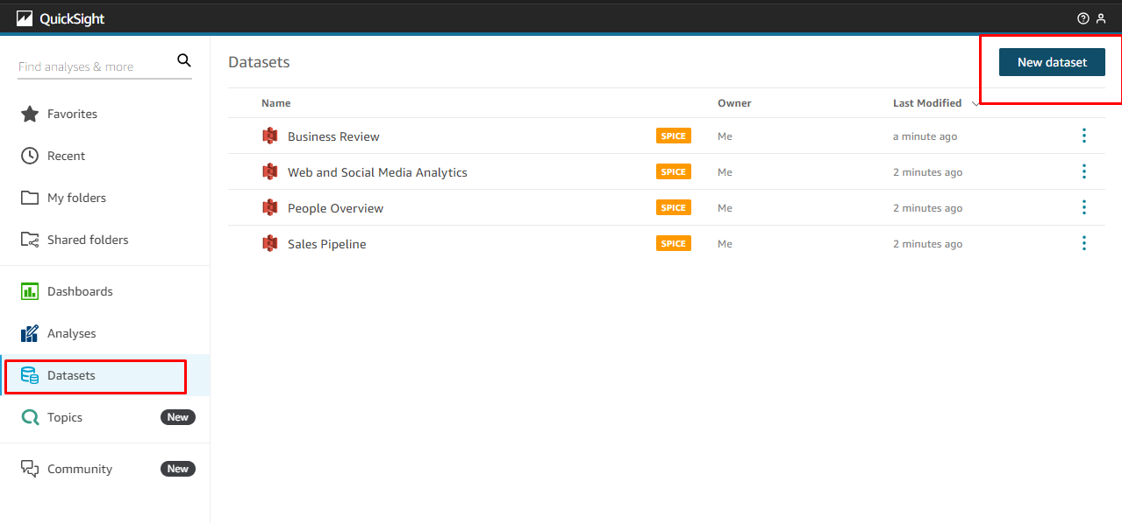

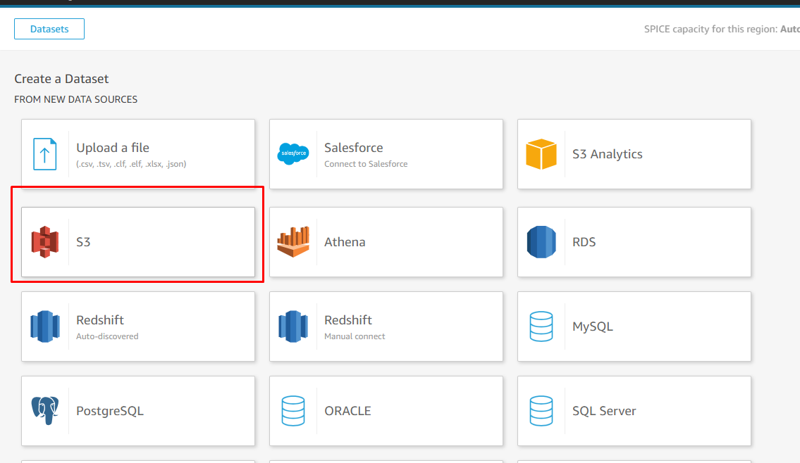

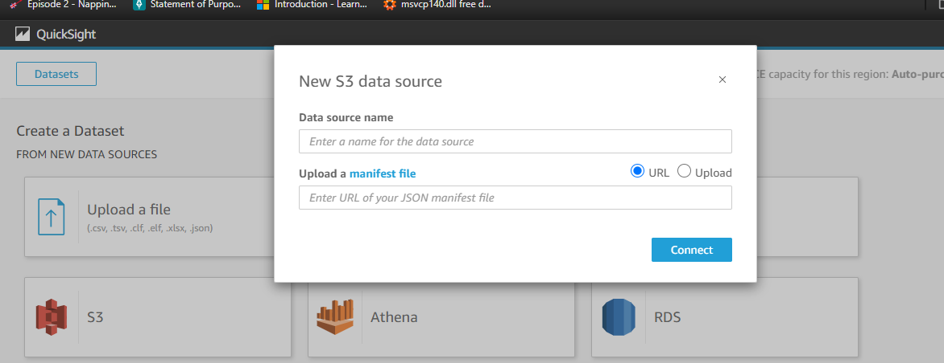

* Back to the s3 tab click on manifest.jason file
* This pretty much provide instruction for quicksight to import the necessary csv file

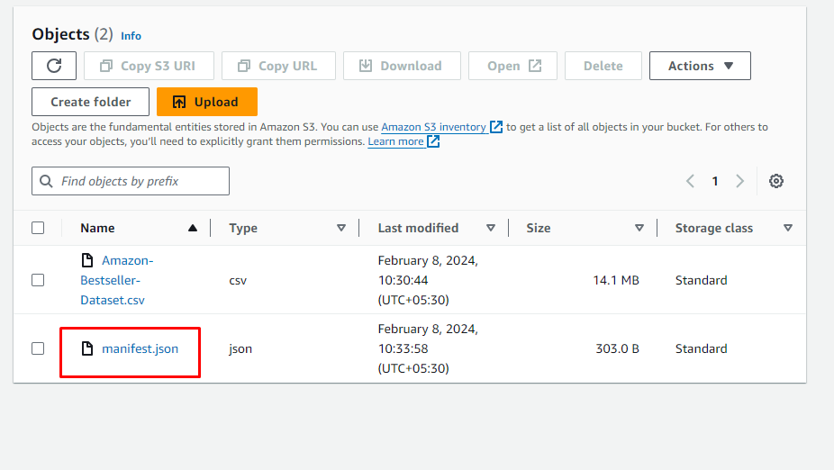

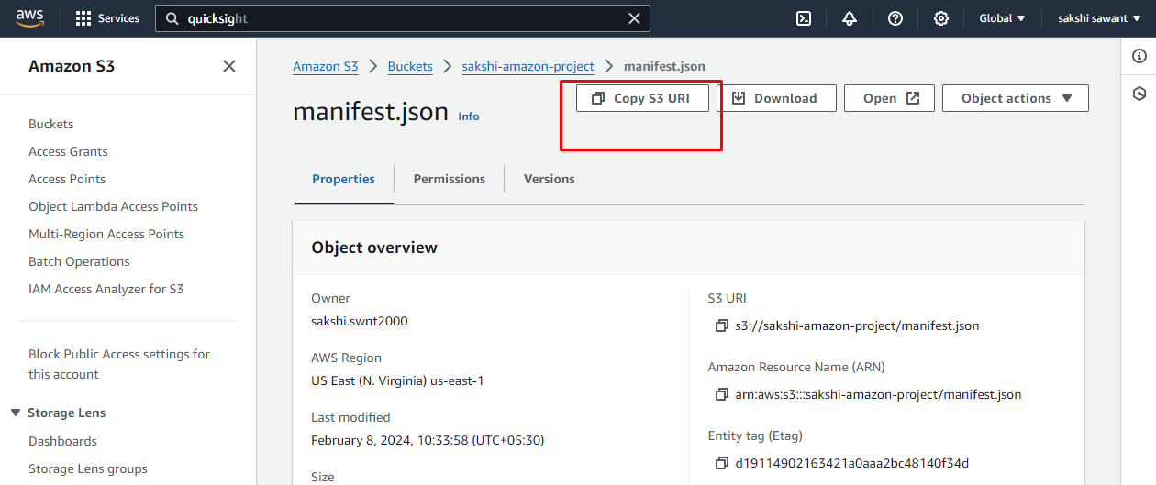

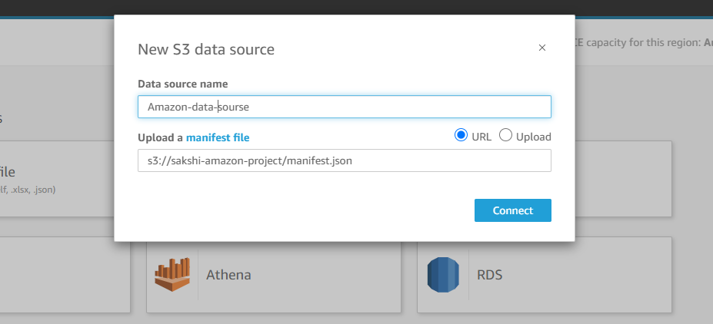

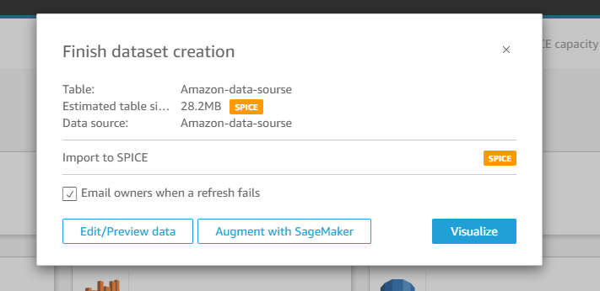

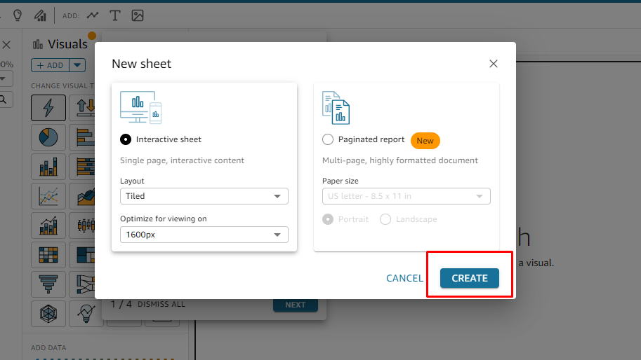

* Give a few minutes to your dataset to get imported
* You can already see that your the column names have been imported already

Step #4: Create Visualizations

* Now we are ready to create our first visualization.
* I am going to name this sheet as most popular brands
* Drag fields into the graph to create visualizations (e.g., Most popular brands).
* Sort, filter, and customize the graphs as desired.
* Experiment with different types of graphs like bar charts, pie charts, line graphs, etc.

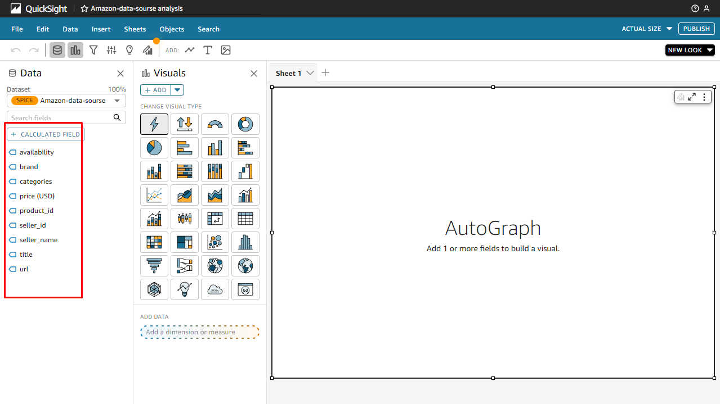

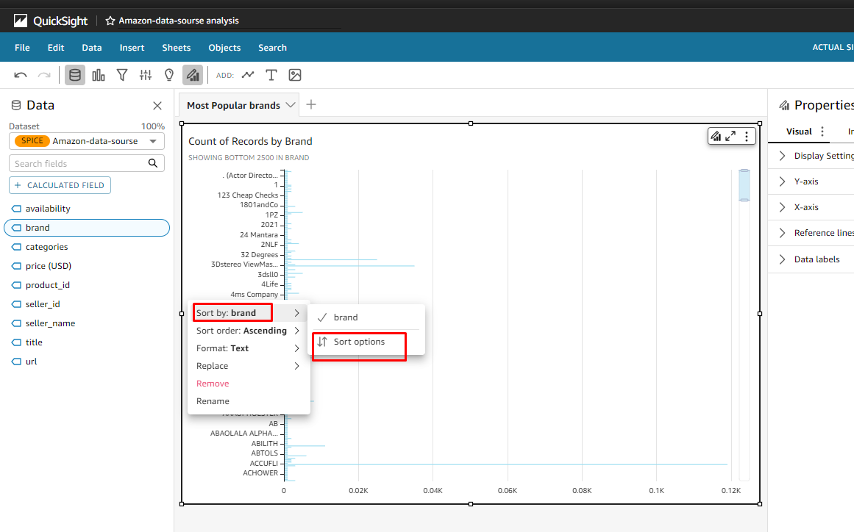

* Here we can see that the amazon quicksight has sorted the brand names by most popular brands

